**Lesson Notes**

1. What is the main purpose of an Operating System?

An operating system is simpler and handles the computer hardware and the resource allocation. It also has a consistent user experience and provides standard user interface and a standard way to browse data files and folders. It runs multiple applications at the same time.

1. What is the difference between Operating System Software and Use Application Software?

The differences are the same application can run on different computer hardware’s and the operating system must be configured according to the hardware components in the computer. Also the applications focus on what is contained and displayed within the window while the operating system controls opening, closing, resizing windows and the response from mouse to keyboard actions. Operating system also provides standard ways to print, open and save files and accessing the internet. For resource allocation applications just ask what they need while operating systems check for the availability and coordinates resource allocation between applications.

1. What is the difference between Operating System Software and Computer Hardware?

Some applications can run on different computer hardware’s but the operating system must be configured to hardware components that are present in the computer.

1. What are the main parts of an Operating System?

The main parts of a operating system is the Graphical User Interface, system calls, device drivers, I/O Manager, Memory manager, process manager, and the security monitor.

1. What are some popular operating systems?

Some popular operating systems are the Windows OS, Mac OS, Linux / Unix, Android, and IOS

**Reference Diagram**

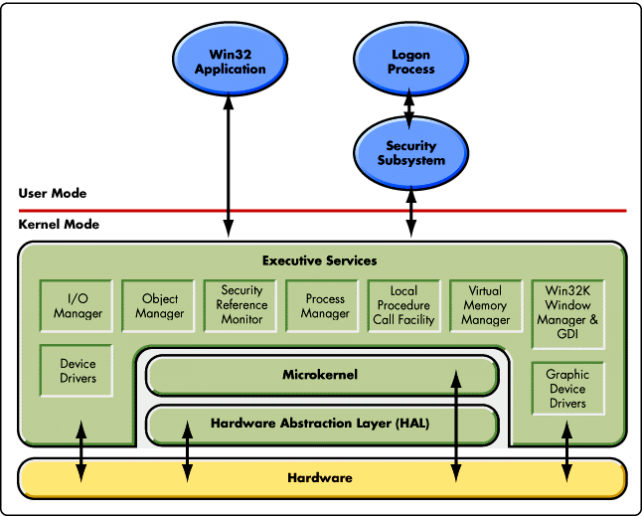

**Student Questions**

1. What is a device driver?
   1. Provide a brief summary

A device driver is a file that lets the computer know the configuration and specifications of a certain hardware device.

* 1. List some devices that require a device driver.

Hard drives, DVD drives, and PCI cards.

* 1. Provide a label on the reference diagram for the location of a device driver for your graphics card.
  2. Provide a label on the reference diagram for the location of a device driver for a locally attached printer.



Device Driver for Graphics Card

Device Driver for locally attached printer

1. What is a DLL?
   1. Provide a brief summary

DLL are files which are nothing more than a means for developers to use a shared code and data. It allows upgrades to functionalities without the need to re-compile or re-link applications.

* 1. Explain how DLLs are related to user application programs

DLLs are used to re-link files and re-compile files while User application programs is used to group together programs, word processors, database programs, web browsers, and spreadsheets.

* 1. Provide a label on the reference diagram for the location of a DLL



DLL

1. What is a windows manager?
   1. Provide a brief summary

It is a system software that controls the placement and appearance of windows which is inside a window system in a graphical user interface.

* 1. Explain how a windows manager is related to user application programs

A windows manager controls the placement and appearances of windows which is within the graphical user interface and the user application is a group of applications or groups of programs. For the Windows manager to work it needs the user application program to be running.

* 1. Provide a label on the reference diagram for the location of a DLL

1. What is the windows task manager?
   1. Provide a brief summary

It is a windows feature that provides the details about programs that are running on your computer and displays the most usede performance measures for processes.

* 1. List and explain four (4) types of system information provided by the task manager

It provides information about the I/O details, Virtual memory manager , Object manager, Process manager.

* 1. Provide a label on the reference diagram for the operating system components related to each type of information.



Process Manager

Virtual Memory Manager

Object Manager

I/O Managger